- We expect the Monetary Policy Committee will keep Bank Rate on hold at its next meeting on August 1, but we think the decision will be a close call. The conditions are in place for the MPC to cut, but we think they will wait until September to avoid surprising markets.
- The hawkish reaction of markets to June's inflation data will be the decisive factor. The fact that those members who might switch to voting for a cut, particularly the Governor, have chosen not to speak since the June meeting suggests a lack of urgency on their part.
- But we expect the MPC to use the Monetary Policy Report and press conference to tee up a September rate cut. The more dovish members will reiterate that they are adopting a more forward-looking approach than they have over the past couple of years, supplementing that message with a forecast that shows inflation clearly below target at the two-year horizon.
The minutes of June's Bank of England Monetary Policy Committee meeting revealed that the seven members voting for no change had split into two camps. The hawks said that recent overshoots for services inflation had reinforced their concerns about inflation persistence (Chart 1). In contrast, the doves suggested they were placing less weight on backward-looking measures of inflation persistence and were adopting a more forward-looking approach. This group said that June's decision was finely balanced and suggested that August's forecast update would be pivotal.
We don't know how many members are in each camp. But the language used in the minutes suggests there would be enough members of the dovish camp to form a majority for rate cuts, alongside Swati Dhingra and Dave Ramsden, who have already been voting for a cut. Indeed, even Huw Pill, who we see as being the most hawkish of the internal members, has said that it's a case of when, not if, the MPC will cut. But whether the first move comes in August or September is a very close call, so it's useful to set out the arguments in favour of each option.
Chart 1: The BoE's favoured measures of inflation persistence have sent mixed signals
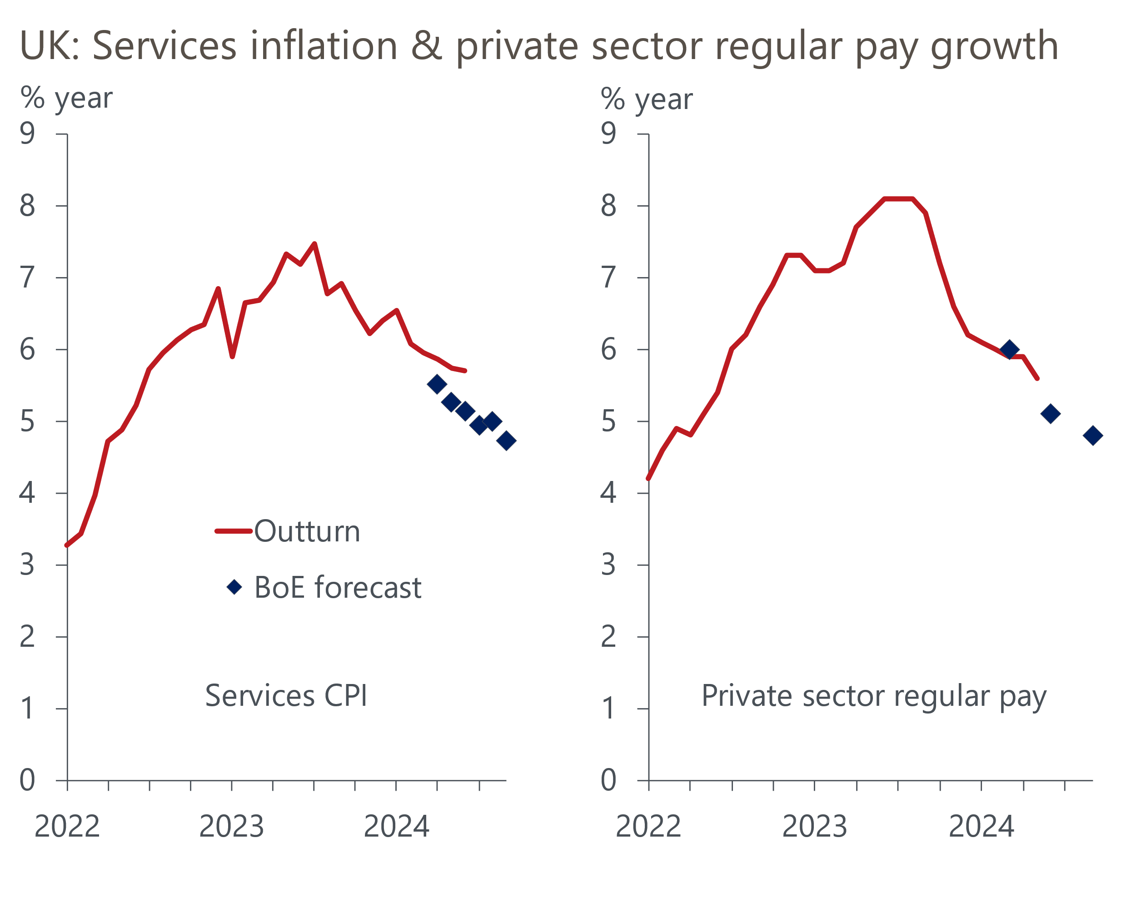
Sources: Haver Analytics, Bank of England Monetary Policy Report, May 2024

Forecast changes and QT separation favour August
Inflation forecast is likely to be lower at the two-year horizon. The June minutes suggested the forecast process for inflation will be a key factor in deciding whether the doves vote to cut. Their near-term forecast will be higher, as it will take on board the recent data. But what matters for policy is the forecast for two years' time. Sterling is now around 2.4% stronger on a trade-weighted basis than the assumption used in May's projection, so this should push the inflation forecast down a little. In addition, the May forecast showed inflation dropping further below target as time progressed. So all else equal, the forecast over a two-year horizon will be lower than before. It could be as low as 1.7%, which would bolster the case for an immediate cut.
Forward-looking inflation indicators are supportive of rate cuts. In June, the doves had cited the risk that now inflation was back in line with the target, inflationary dynamics could "adjust as rapidly on the downside as they had done on the upside". Pay growth has continued to soften in the interim, broadly in line with the BoE staff forecast in May's Monetary Policy Report. Survey data is consistent with the idea that inflationary pressures will continue to soften further out. The BoE Decision Maker Panel reported a further fall in firms' expectations for inflation and pay growth over the coming year. The Citi/YouGov survey also reported that inflation expectations for horizons ranging from one year to five years to 10 years had fallen to their lowest levels since H1 2020.
June inflation data doesn't change the doves' core narrative. Markets were spooked when June's outturn for services inflation came in 0.6ppts above the Bank of England staff forecast. But we doubt these concerns will be shared by the doves. Two-thirds of the overshoot dates from April's larger-than-expected uprating of index-linked contracts and regulated prices. June's minutes suggested the doves were relaxed about that development.
So it was only the extra 0.2ppts in June's data that was "news". But we doubt the doves will be put off by that either. The Office for National Statistics publishes the individual price quotes that feed into the CPI, and this dataset showed exceptionally high month-on-month increases in prices for two hotels between May and June (Chart 2). These hotels were in the North West and Wales, with the date that most of the price quotes were collected being around the time that Taylor Swift's Eras tour rolled into Liverpool.
Chart 2: Most of June's overshoot for services inflation can be traced back to very large price rises in two hotels
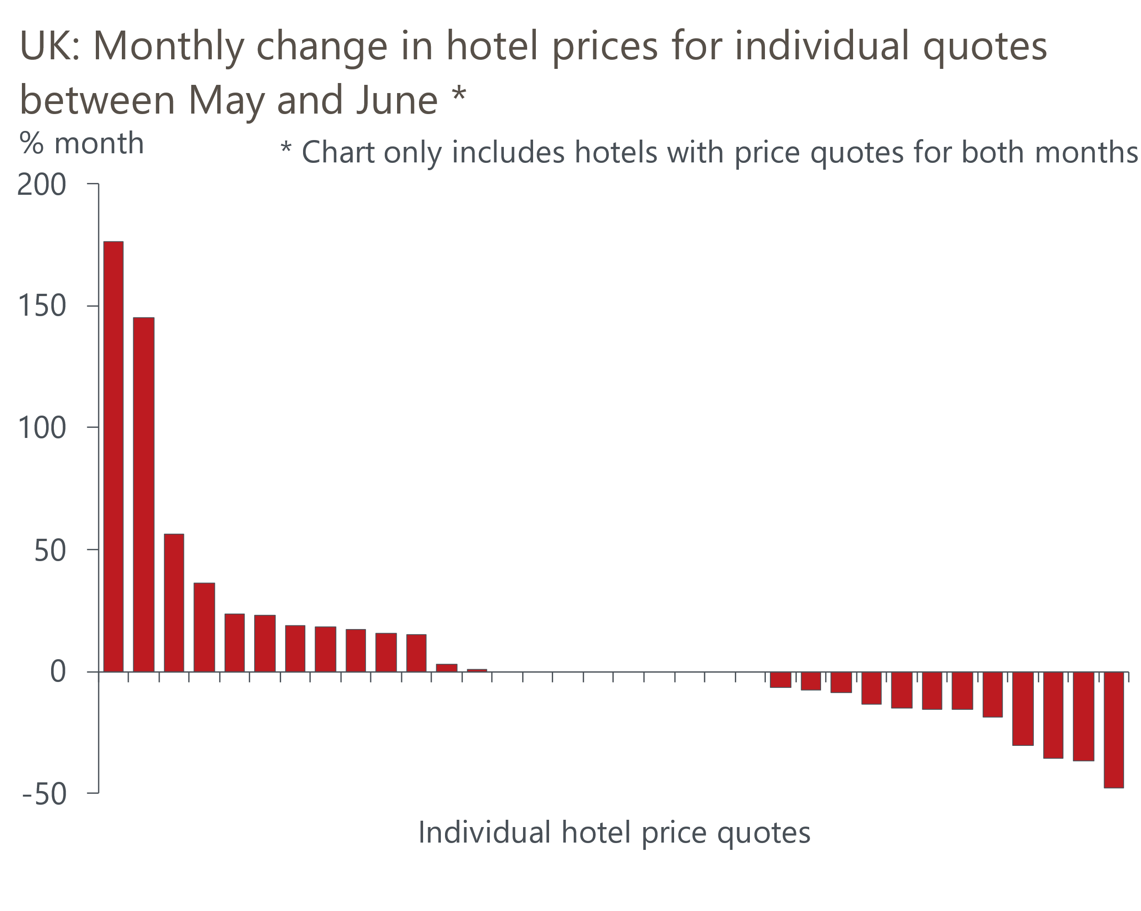
Source: Oxford Economics calculations using data from ONS
We calculate that had prices in the accommodation services category risen by the average month-on-month change seen over the past 25 years, services inflation would have been 0.2ppts lower in June. So most of the overshoot can be attributed to noise and will likely unwind over the coming months, particularly if it is Swift-related.
An August cut will separate interest rate and quantitative tightening decisions. At the September meeting, the MPC is due to announce its decision over the pace of QT over the coming year. The BoE has always emphasised that the decisions about QT and interest rates are separate from one another. From a presentational perspective, the MPC would probably prefer to avoid making important decisions on both at the same meeting. That would be even more important if the MPC opted to reduce the pace of QT, although this is not our baseline forecast.

Market pricing and the MPC's lack of urgency favour September
Markets expect rates to stay on hold in August. The biggest bar to an August cut is financial market pricing. Before the recent inflation release, market pricing had moved narrowly in favour of a move next week. But as of market close on July 23, the implied probability of an August cut was just 42%. The MPC hasn't gone against the market consensus since November 2021. Though not completely beholden to markets, we think the MPC would prefer to take markets with them rather than take them by surprise, particularly if there is little urgency.
Silence from key MPC members suggests a lack of urgency to cut. Whether deliberately or not, the doves have given the impression there is little urgency by their silence. Though election speaking restrictions prevented committee members from making public comments up to July 4, they’ve since had three weeks to air their views. Several of the more hawkish members took the opportunity to confirm that their views hadn't changed (the comments made by MPC members since June's meeting are summarised in Table 1). Markets viewed Pill's speech as being hawkish, though we saw it as having something for everyone, with no clear message. But none of those who we think might switch to voting for a cut have provided any on-the-record commentary since the June meeting, suggesting a lack of urgency on their part.
The silence of Governor Andrew Bailey is particularly telling. Bailey is likely to be the pivotal voter. The internal members have tended to vote as a bloc in recent years, and it's very unusual for the Governor to find themselves in the minority – Mervyn King was the last Governor to vote against the majority in June 2007. An intervention from the Governor over the past week would almost certainly have been enough to get markets onside for an August cut. That he opted not to speak sends a message itself.

We narrowly favour September for the first cut, with market pricing key
It’s clear that August's decision is on a knife edge. But with inflation at target and the economy growing at a solid pace in H1 2024, the need to cut isn't urgent. Furthermore, a press conference and Monetary Policy Report provide the opportunity to set the narrative ahead of the September meeting.
While it wouldn't be a surprise if there was a narrow majority to cut in August, we think the more likely outcome is another vote to hold. But we expect the minutes and press conference will lay out the case for cutting soon, leaving the clear impression that a September cut is likely.

Table 1: Key comments by MPC members
Speaker and link | Date | Key takeaway
Dhingra | 15-Jul | The first MPC member to start voting for cuts, Dhingra argued that high interest rates "are weighing on living standards and that cost does not need to be paid".
Pill | 10-Jul | The BoE's Chief Economist remarked that on one hand, the latest data remained consistent with the view that inflationary pressures "have now been contained and may be starting to revert towards levels that are more consistent with the inflation target". But on the other hand, he also noted that the key drivers of UK inflation were still showing "uncomfortable strength".
Mann | 10-Jul | Mann said the fact that inflation would rise later this year "matters for my decision making". She also suggested she wouldn't contemplate voting for rate cuts until she had observed a "sustained deceleration" in services inflation.
Haskel | 8-Jul | In his final speech as a member of the MPC, Haskel said that the playing out of recent inflation shocks, and the continued tight and impaired labour market, would mean "inflation will remain above target for quite some time". In that environment, he said he would "rather hold rates until there is more certainty that underlying inflationary pressures have subsided sustainably".
Sources: Bank of England, Reuters

